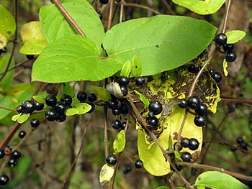
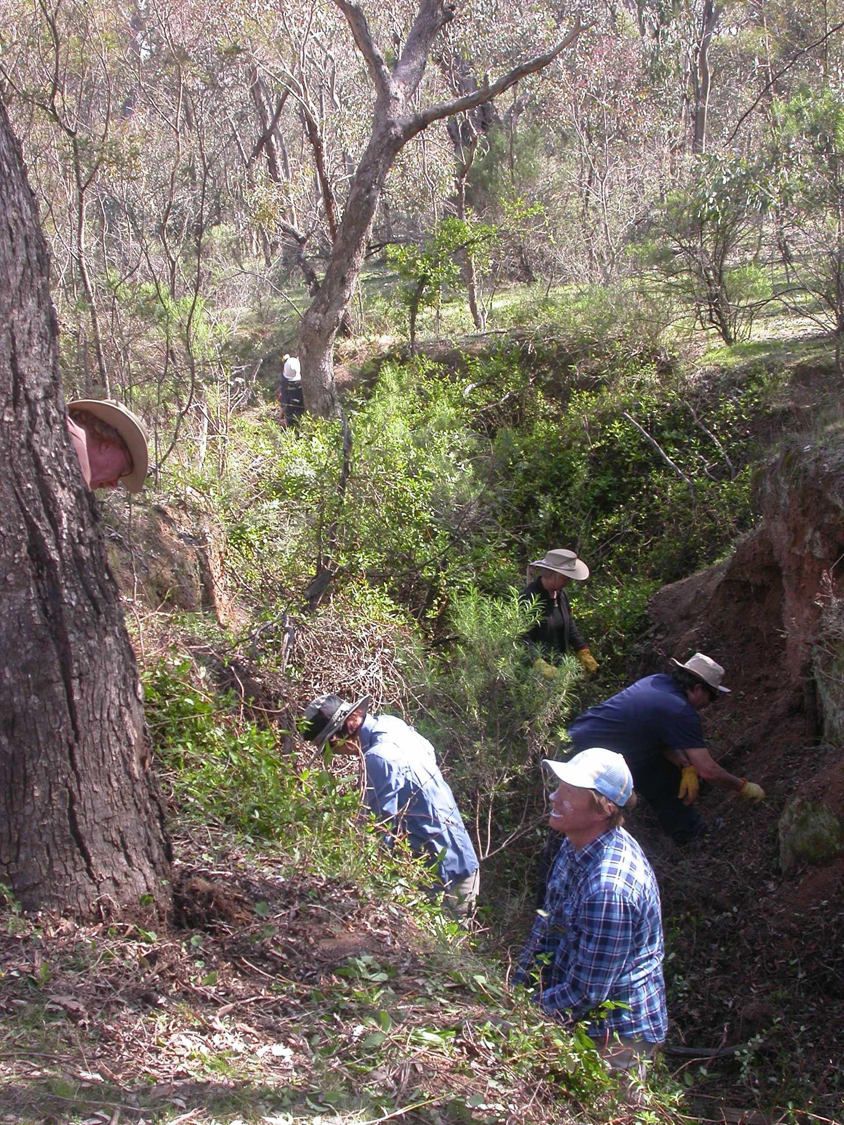
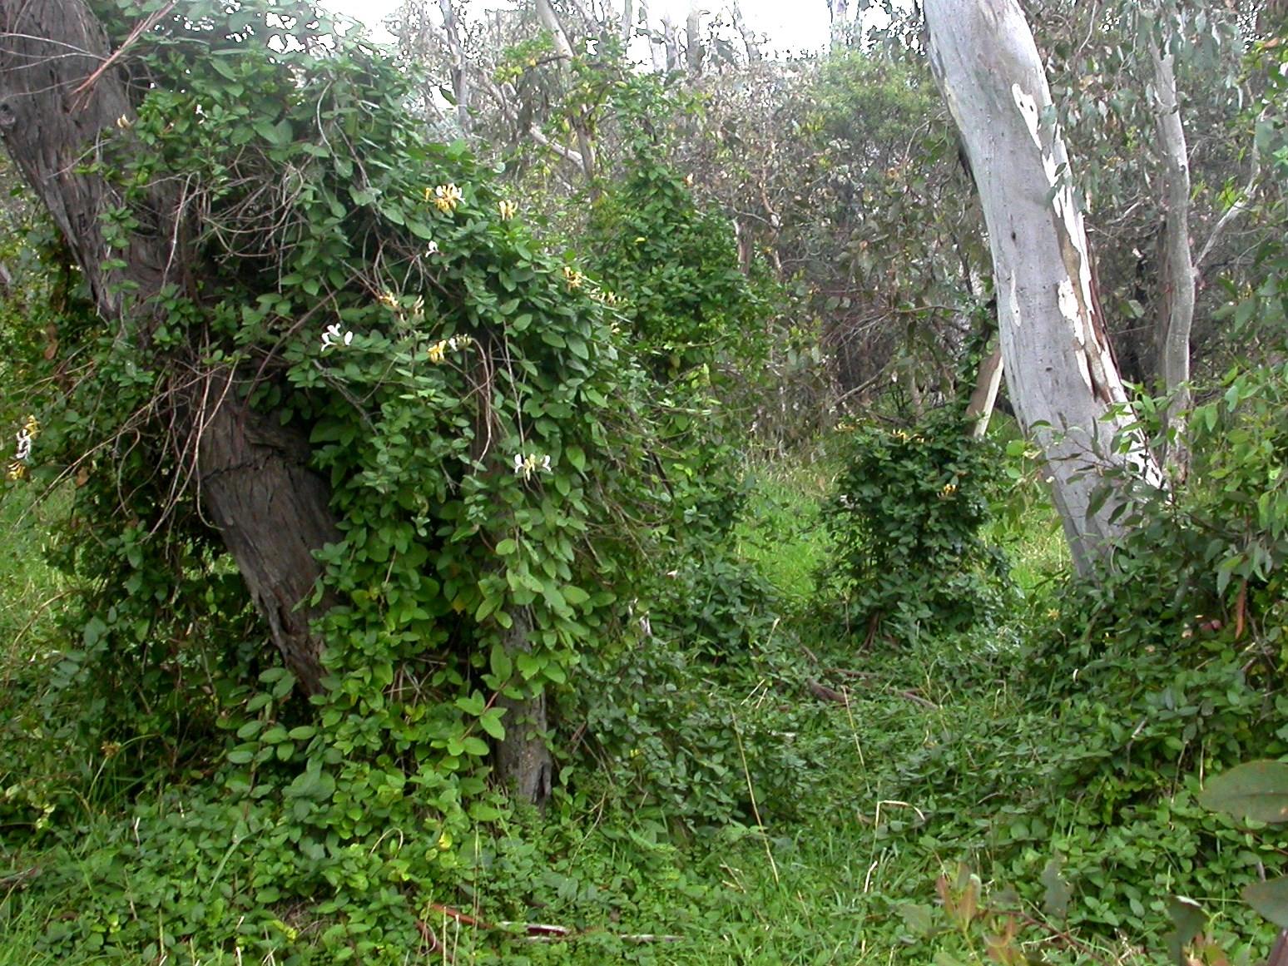

Friends of Mount Majura
Working Party
Sunday, 30 April, 9am - 12noon
Meet: Nature park entry close to Mackenzie Street intersection with Russell Street and Hull Place (south of 85 Mackenzie St)
What: Removal of Japanese Honeysuckle
Bring: Sun protection, sturdy shoes, body-covering clothing.
Please come early for an introduction and give as much time as you like.

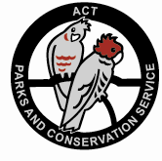
Further information and map
www.majura.au
Photos (W. Pix) from left: Honeysuckle smothering native plants in the Mt Ainslie nature reserve; Removal of Honeysuckle by Friends of Mt Majura volunteers; Fruiting Honeysuckle

