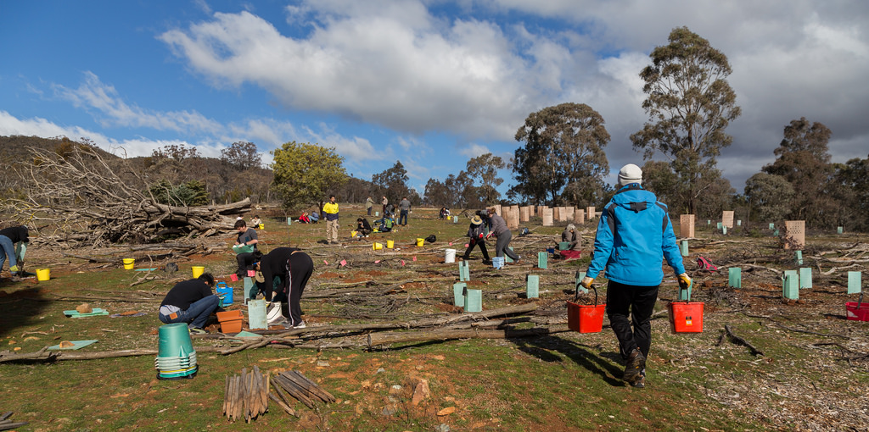**Friends of Mount Majura**

**Working Party**

**Nature Reserve east of The Fair**

**When:** Sunday, 18 June, 1pm – 4pm

**Meet:** Nature park entrance Tay/Ian Nicol Streets, The Fair, North Watson.

**What:** Spreading mulch; direct seeding of native grass.

**Bring:** Sun protection, sturdy shoes; tools and tea will be provided.

**Give as much of your time as you want.**

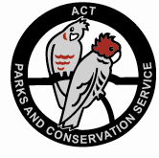For more information

[www.majura.au](http://www.majura.au)

Photograph: National Tree Day planting July 2016 (S. Bittinger)