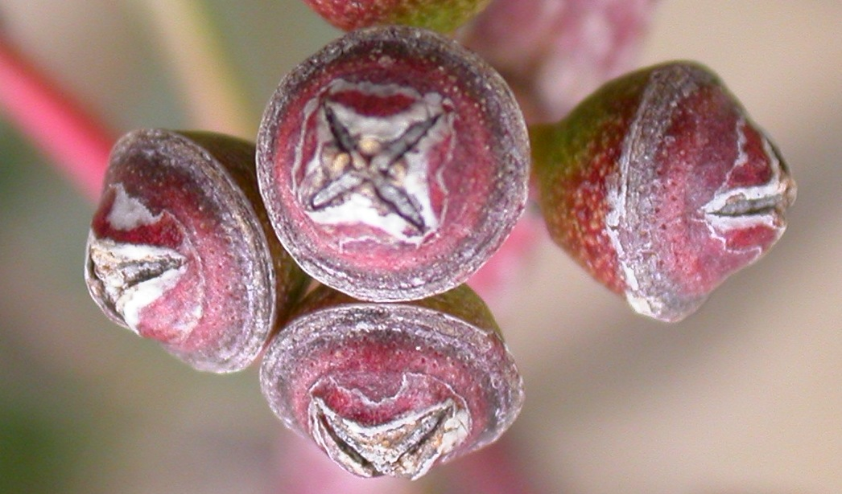
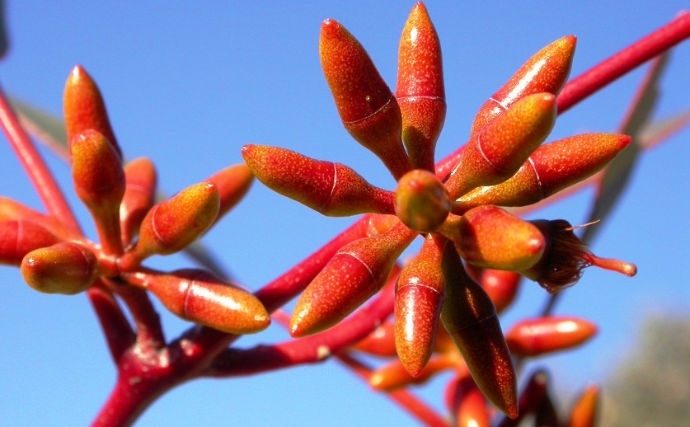
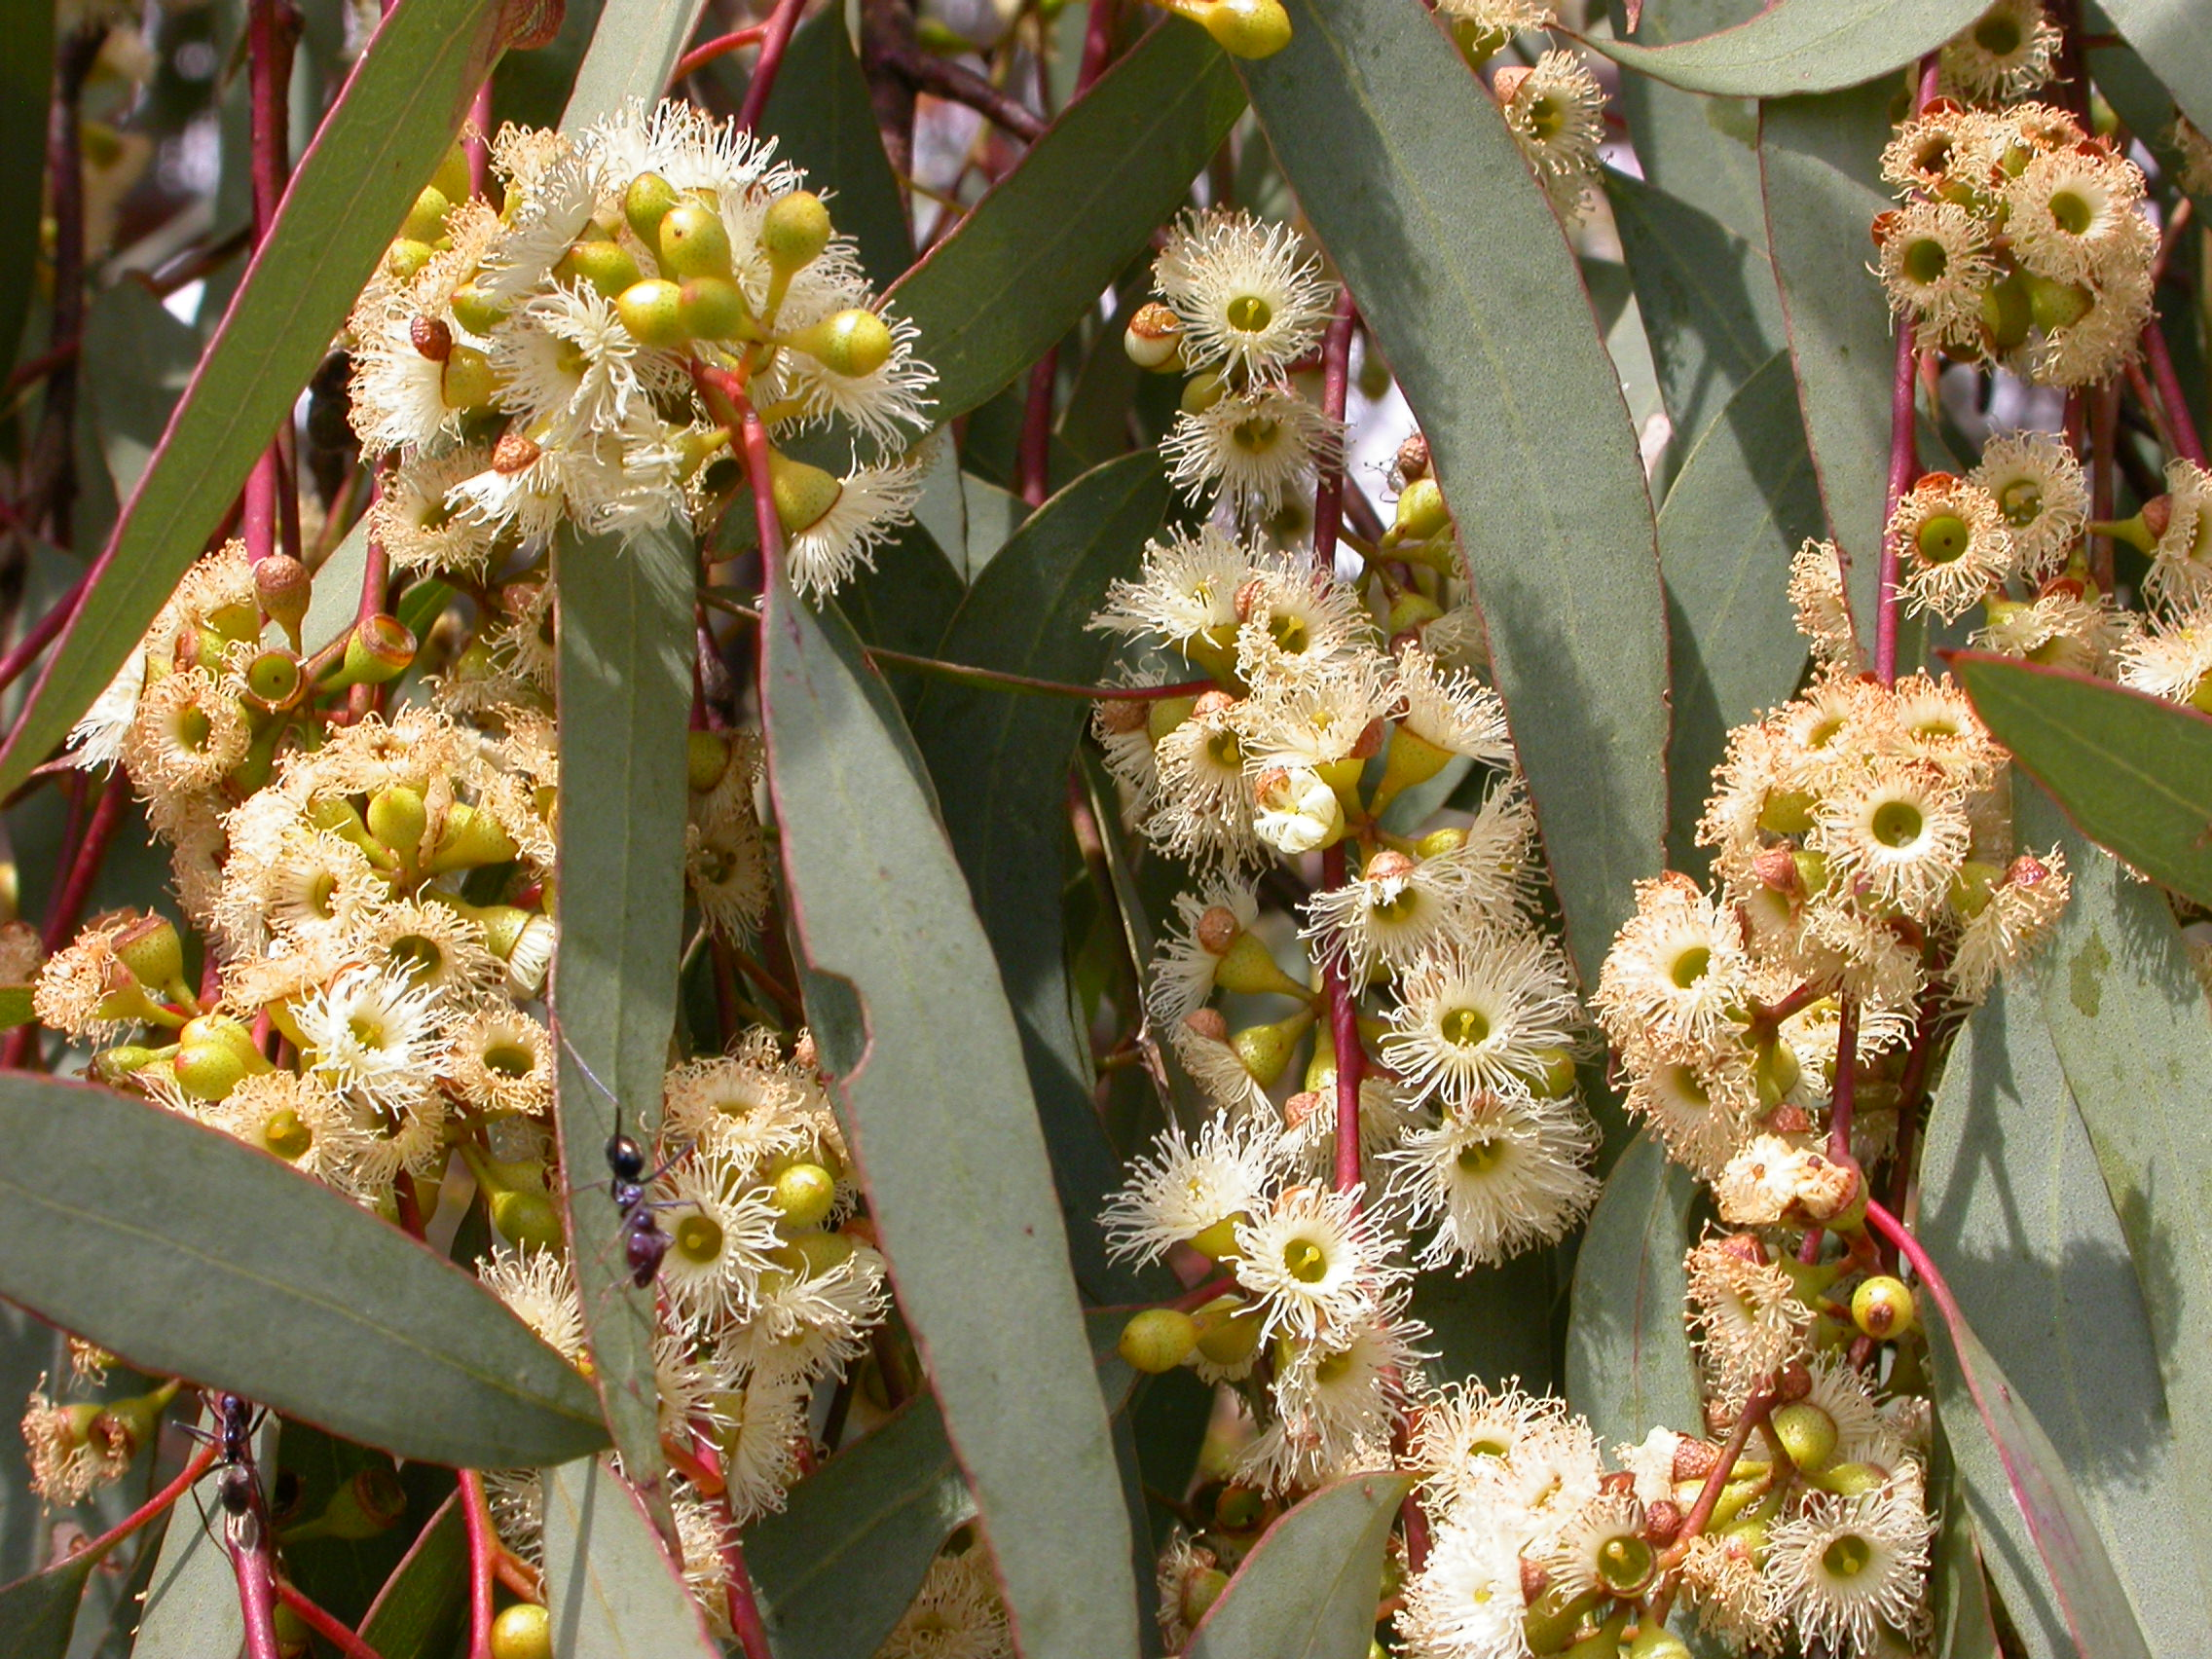
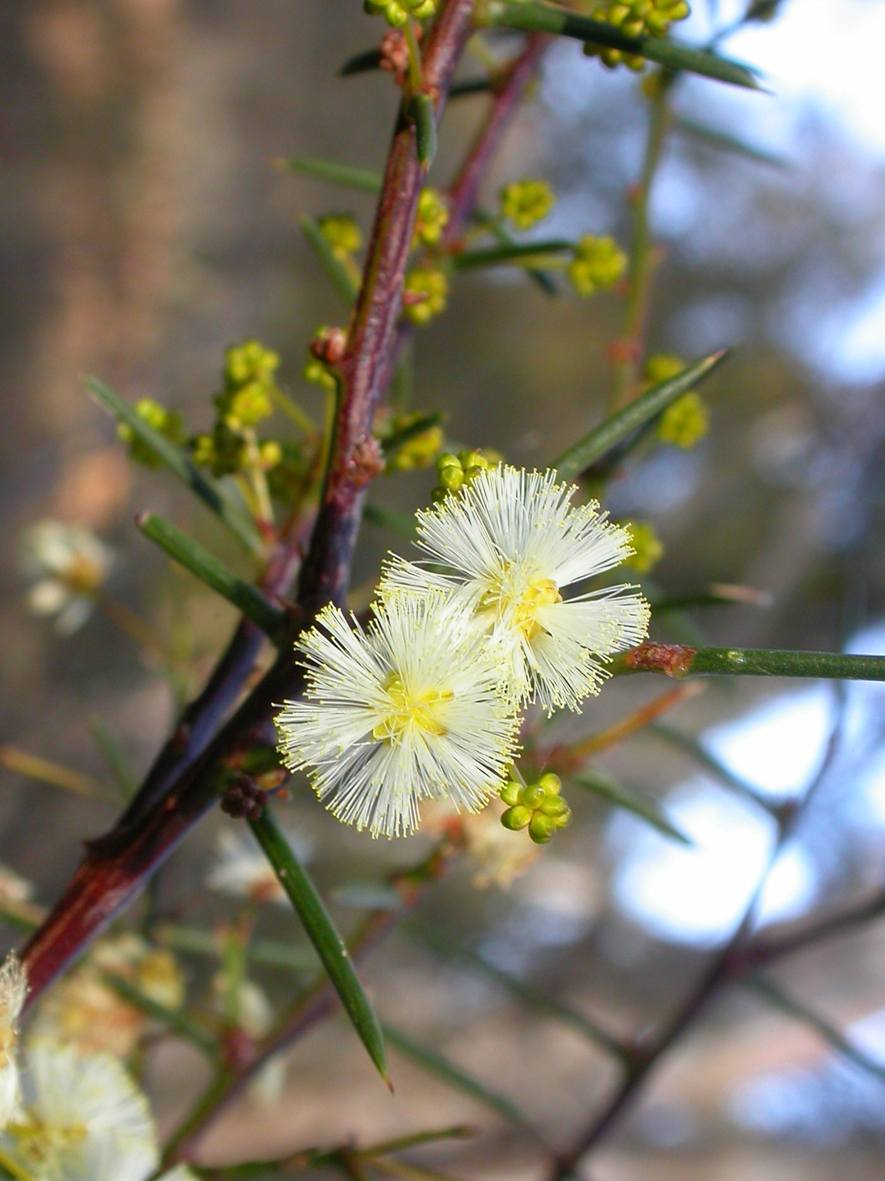
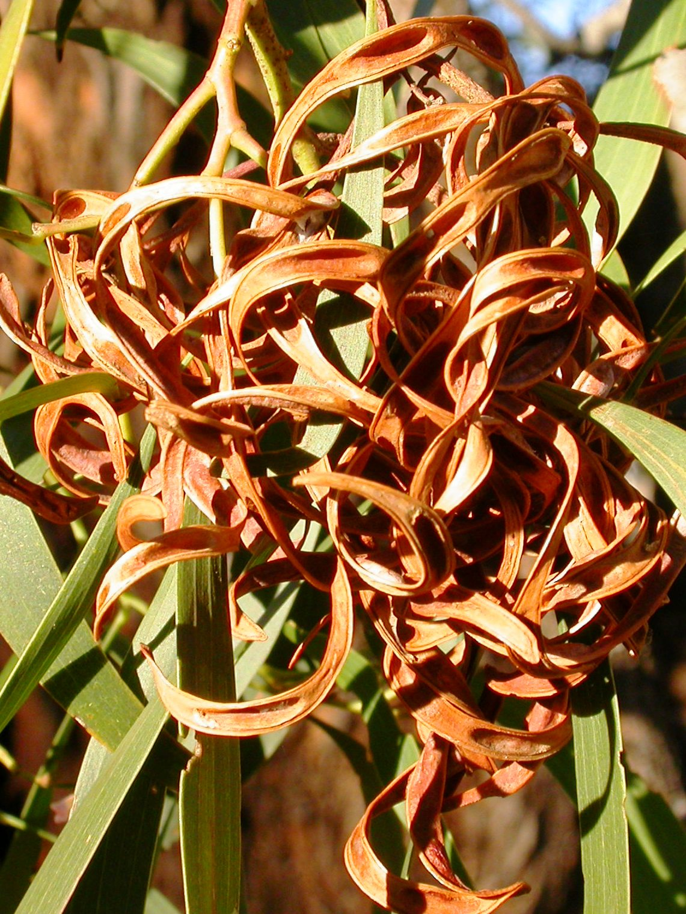
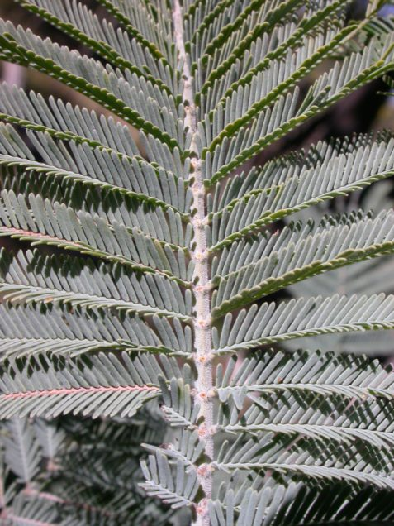
National Tree Day 2017
List of Species

Acacia dealbata – Silver Wattle
Acacia genistifolia – Spreading Wattle
Acacia implexa – Hickory
Acacia paradoxa – Kangaroo Thorn
Bulbine bulbosa – Native Leek
Bursaria lasiophylla – Native Boxthorn
Eucalyptus blakelyi – Blakely’s Red Gum
Eucalyptus melliodora – Yellow Box
Xerochrysum viscosum – Sticky Everlasting

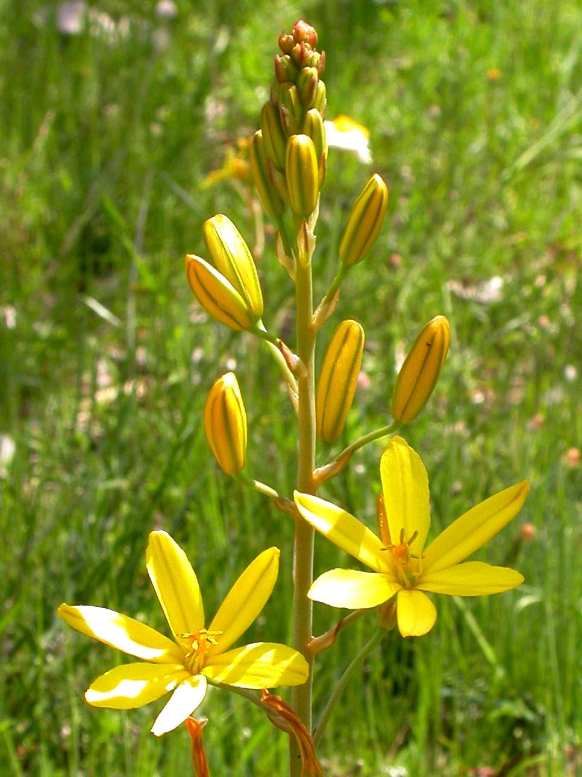
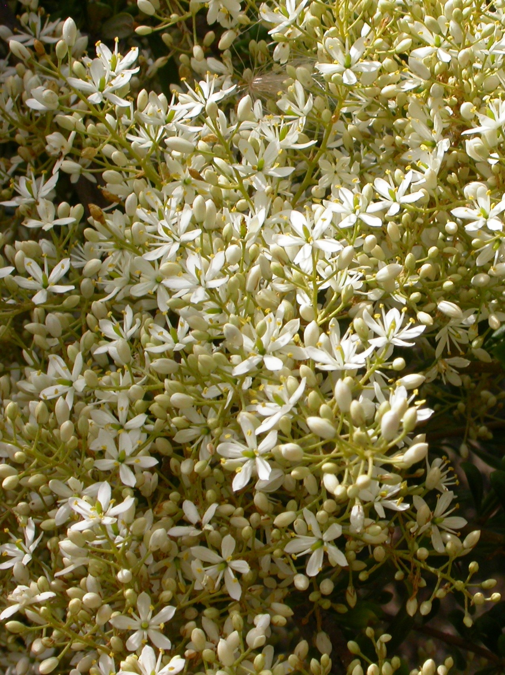
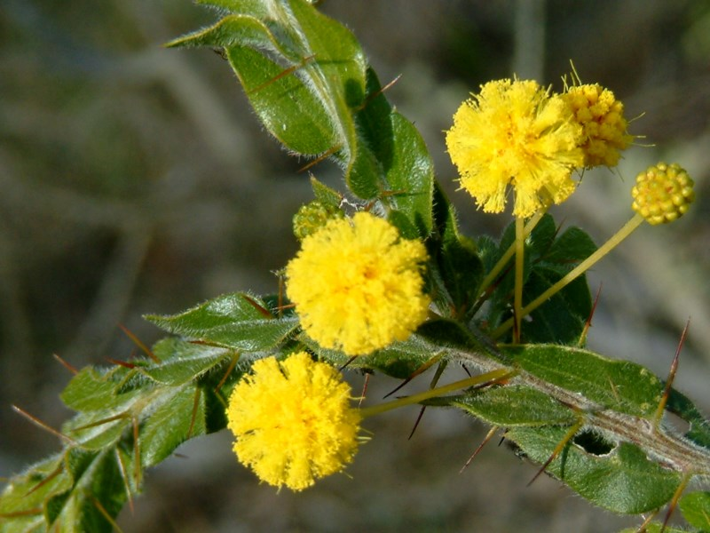
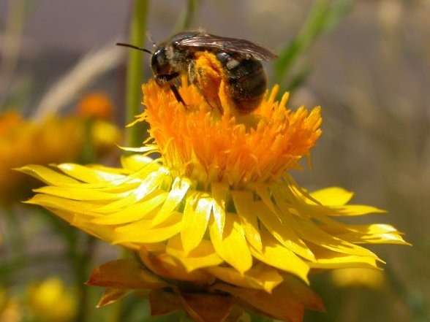

Photographs (W. Pix) clockwise from top left: Blakely’s Red Gum flower buds, Blakely’s Red Gum fruits, Yellow Box flowers, Spreading Wattle flowers and leaves, Hickory pods, Silver Wattle leaf, Native Boxthorn flowers, Kangaroo Thorn flowers and leaves, Sticky Everlasting compound flower head with native bee, Native Leek.

