Friends of Mount Majura
BIRD WALK
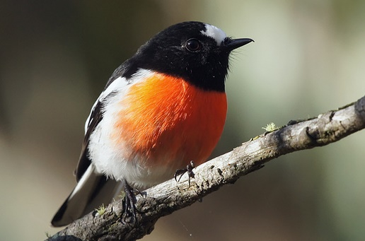
Scarlet robin by David Cook
Sunday 22 October 8-10am
Mount Majura Nature Reserve
Meet at Mt Majura nature reserve entrance off Tay / Ian Nicol Streets, east of The Fair, North Watson.
Walk through Mt Majura’s woodlands with bird enthusiast Peter Miller to spot, observe, listen to, identify and learn about the amazing variety of birds in Spring.
Bring binoculars, a bird field guide or Morcombe’s birds of Australia app ($30 online); a Gold Coin donation for Mt Majura’s bird species list.
Find out more: www.majura.org

