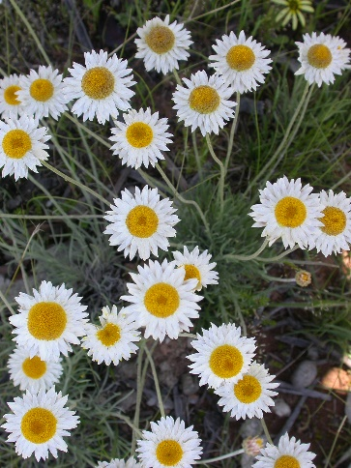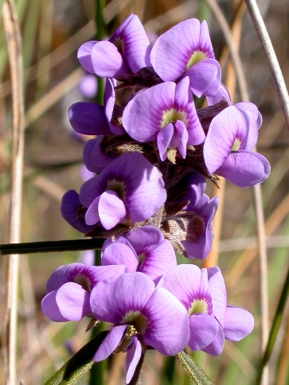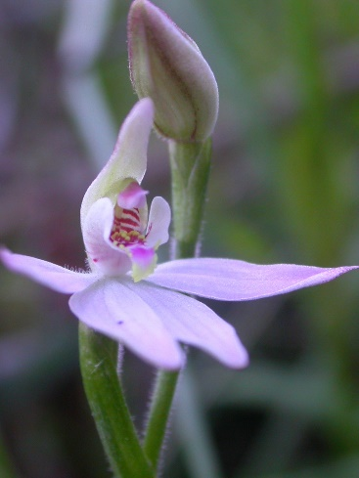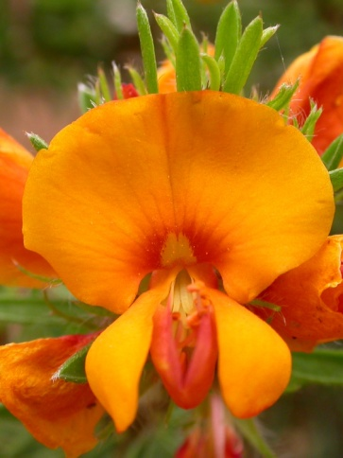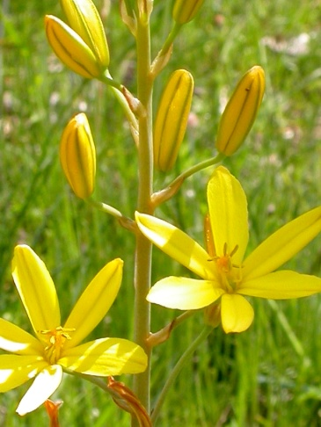Friends of Mount Majura

**WILDFLOWER WALK**

**Sunday, 15th October 2 - 4 pm**

**Meet** at nature reserve entrance off Antill St, North Watson roughly opposite Carotel between Prime TV and a small roundabout.

Explore and enjoy the wildflowers that bloom this season at a delightful walk with local plant ecologist Michael Doherty.

**Bring** magnifying glass, camera, walking boots, sun protection and a gold coin donation for a flora list.

Find out more:

[**www.majura.org**](http://www.majura.org)

Photos from left: Pink Fingers, Bulbine Lily, Hoary Sunray, Bush-pea, Creeping Hovea

bump@webone.com.au

bump@webone.com.au

bump@webone.com.au

bump@webone.com.au

bump@webone.com.au

bump@webone.com.au

bump@webone.com.au

bump@webone.com.au

bump@webone.com.au

bump@webone.com.au