Friends of Mount Majura
BIRD WALK
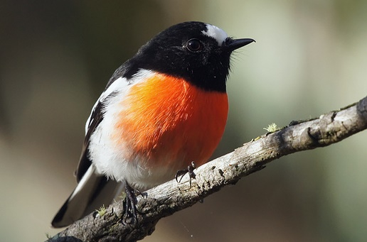
Scarlet robin by David Cook
Sunday 26 July
8am (sharp) to 10am
Mount Majura Nature Reserve
Meet at nature reserve entrance close to Tay St /
Ian Nicol St intersection at The Fair, North Watson.
Walk through woodlands with bird enthusiast Peter Miller to observe, listen to, identify and learn about the amazing variety of birds on Mt Majura.
Bring: Binoculars, walking boots, water, bird ID book or app, AND Gold Coin donation for a bird list.
Enquiries: secretary@majura.org

